**Press release**

Successful balance 2024:   
Nearly 40,000 tonnes of agricultural plastics recycled through initiative ERDE

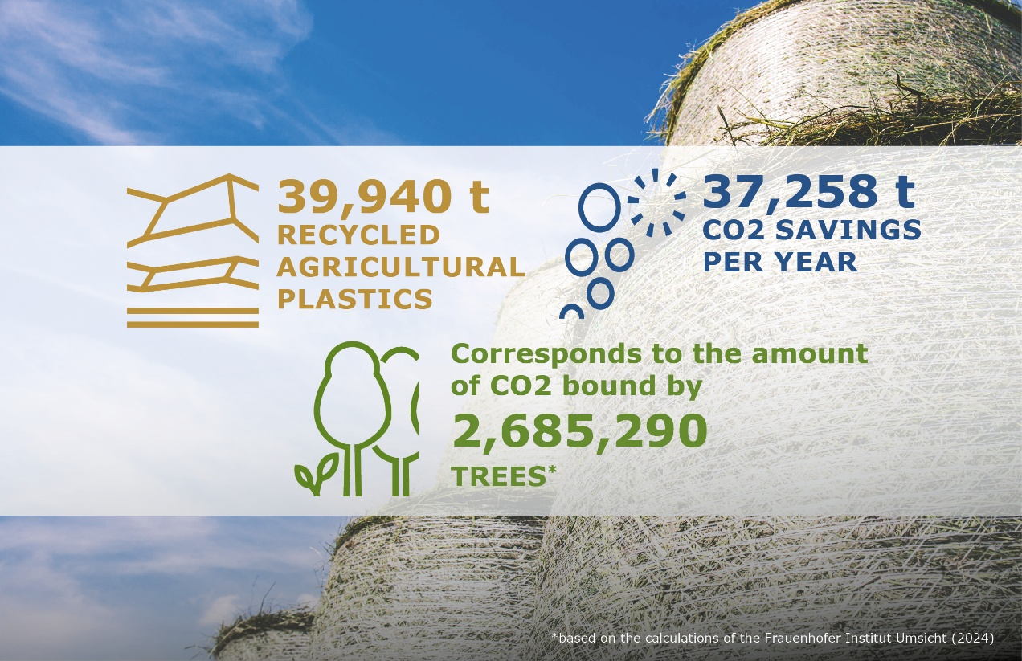

*Successful effort for the environment and climate, turning used agricultural plastics into new resources! © RIGK*

Wiesbaden, Bad Homburg, April 2025 – The initiative **[ERDE](http://www.erde-recycling.de)** (**E**rntekunststoffe **R**ecycling **De**utschland – recovery and recycling system for crop plastics in Germany) achieved a new record result in 2024 with 39,940 tonnes of recycled agricultural plastics, which it sees as a clear signal of the growing involvement of agricultural businesses, retailers, and collection points. Through the take-back and material recycling of these quantities, 37,258 tonnes of CO₂ equivalents were saved. This is equivalent to approximately 324 million car kilometers, 3,500 hectares of forest, or the carbon sequestration capacity of over 2.6 million trees.

Boris Emmel, System Manager of the initiative ERDE, added: "The fact that we were able to recycle nearly 40,000 tonnes of agricultural plastics in 2024 is a powerful statement. Agriculture is taking responsibility, and our collaboration with manufacturers, retailers, and agricultural businesses is working very well. With every tonne that is returned and recycled, we are collectively making a significant contribution to climate protection."

**Strong figures – shared responsibility**

The results of 2024 are the outcome of a collaborative partnership among all stakeholders within the initiative ERDE. Under the umbrella of the IK Industrievereinigung Kunststoffverpackungen e. V. (German Association for Plastics Packaging and Films), manufacturers, RIGK GmbH as the system operator, agricultural businesses, collection partners, recyclers, and many other participants are committed to a functioning return system. The foundation for this is the voluntarily renewed ERDE self-commitment from 2023, which was submitted to the Federal Ministry for the Environment. It defines ambitious goals, such as a collection rate of over 60% for asparagus films by 2026 and 75% for silo and stretch films by 2027.

Dr. Laura C. Müller, Economic Affairs Specialist at the IK Kunststoffverpackungen Industry Association, confirms: "The continuously rising collection rates demonstrate that shared responsibility works. The industry is living up to its commitments, and ERDE is a prime example of voluntary environmental responsibility in practice."

**Collection season 2025: expansion and new fractions**

The system is starting the new collection season stronger. Greenhouse films and drip tapes, after a successful testing phase, are now permanently part of the collection portfolio. ERDE continues to expand the return system flexibly and specifically where it is needed in practice, with around 700 collection points and over 150 collection partners. As a special recognition for retailers and machinery manufacturers, an ERDE Premium Seal will be awarded to partners who exclusively offer ERDE-licensed products across all ERDE product categories, thus meeting the highest sustainability standards.

ERDE will inform about current developments and new recycling solutions for agriculture at the Agritechnica agricultural fair, taking place in November 2025 in Hannover.

**Conclusion: recycling in agriculture works – a lived commitment to climate protection**

The results of 2024 again underline: sustainable recycling in agriculture succeeds when many stakeholders take responsibility together. This sector, with its complex framework conditions, requires reliable, manufacturer-supported systems and close cooperation along the entire value chain. ERDE shows how this collaboration works in practice and makes a measurable contribution to climate protection.

|  |  |
| --- | --- |
| Further information:  Initiative ERDE  Boris Emmel, System Manager  Friedrichstr. 6  65185 Wiesbaden (Germany)  Phone: +49 611 308600-20  [emmel@rigk.de](mailto:emmel@rigk.de), [erde-recycling.de/en/](http://www.erde-recycling.de/en/) | Editorial contact, sample copies:  Konsens PR GmbH & Co. KG  Dr.-Ing. Jörg Wolters  Hans-Böckler-Straße 20  63811 Stockstadt (Germany)  Phone.: +49 6027/99005-13  [mail@konsens.de](mailto:mail@konsens.de); [www.konsens.de](http://www.konsens.de) |

You can find this press release as a .doc file as well as images in printable resolution for download at https://www.rigk.de/en/worth-knowing/press/