**Press Release**

Register Now – 4th International Recycling Forum on 10–11 December 2024 in Wiesbaden

*[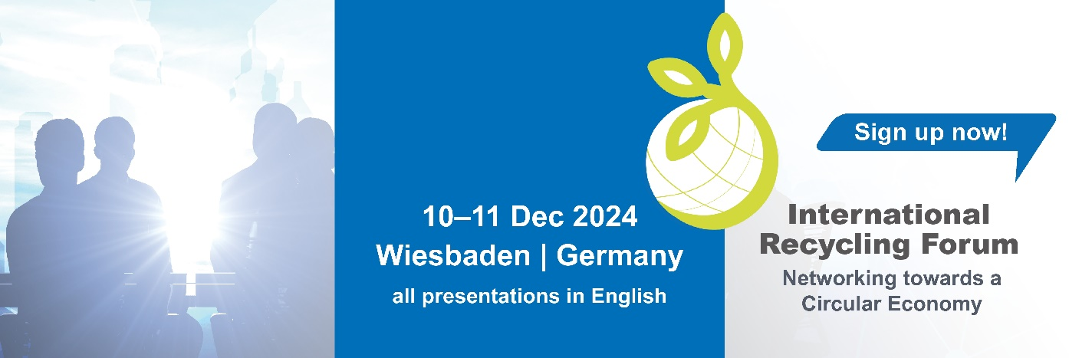](https://www.international-recycling-forum.de/en/)*

Wiesbaden (Germany), October 2024 – The 4th International Recycling Forum will take place on 10 and 11 December 2024 at the Dorint Hotel in Wiesbaden. Organised by RIGK GmbH in collaboration with EPRO, the event brings together international experts and companies to actively shape the future of plastics recycling. Participants can look forward to a diverse programme focusing on developments and challenges in the Circular Economy within the plastics sector.

**Agenda Highlights:**

* **Market Trends and Circular Economy:** An overview of developments and perspectives in the plastics Circular Economy, along with market analyses
* **Extended Producer Responsibility (EPR):** Best practices from the consumer and industrial sectors for plastic packaging
* **PPWR:** The new regulatory requirements and challenges for the plastic packaging value chain
* **Digitalisation and AI:** The role of technologies such as AI in optimising the Circular Economy and their impact on the industry
* **Chemical Recycling:** Perspectives on chemical recycling and its interactions with mechanical recycling
* **Technical Innovations and Recycling in the Agricultural Sector:** Global approaches and innovations in plastics recycling for agriculture
* **Panel Discussions:** Q&A sessions with experts and industry representatives on key topics
* **Networking Opportunities:** Numerous chances for exchange, especially during the evening event at Kurhaus Wiesbaden

Companies such as BASF SE, EREMA Group GmbH, Herbold Meckesheim GmbH, Hessen Trade & Invest GmbH, plastship GmbH, Veridis Technologies B.V., and R.A.M. GmbH will showcase their latest developments and technologies as part of the sponsors and exhibitors. Media partners, including KI Group and Circular Technology, will support the forum, providing comprehensive coverage of the key topics and presentations from numerous renowned experts participating as speakers and panellists.

Mike Jefferson (Managing Director, EPRO) commented: "RIGK and EPRO are excited about the International Recycling Forum, which serves as the perfect platform to network with international experts and jointly develop solutions for a more sustainable Circular Economy with plastics."

For more information and registration, please visit the website: <https://www.international-recycling-forum.de/en/registration>.

**Further information:**

|  |  |
| --- | --- |
| Contact RIGK:  Jan Bauer  Managing Director  +49 611 308600-16  [bauer@rigk.de](mailto:bauer@rigk.de)  Mirco Gattinger  Marketing and Social Media Manager  +49 611 308600-39  [gattinger@rigk.de](mailto:gattinger@rigk.de) | Editorial Contact, Complimentary Copies:  Konsens PR GmbH & Co. KG  Dr.-Ing. Jörg Wolters Hans-Böckler-Straße 20  D-63811 Stockstadt am Main  +49 (0) 60 27 99005-13  [mail@konsens.de](mailto:mail@konsens.de); www.konsens.de |

You can download this press release as a DOCX file, along with the images in print-ready resolution, at www.rigk.de/en/worth-knowing/press.